31.48: a) 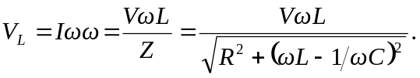
b) 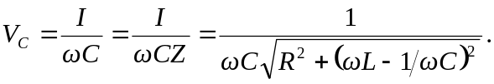
c)
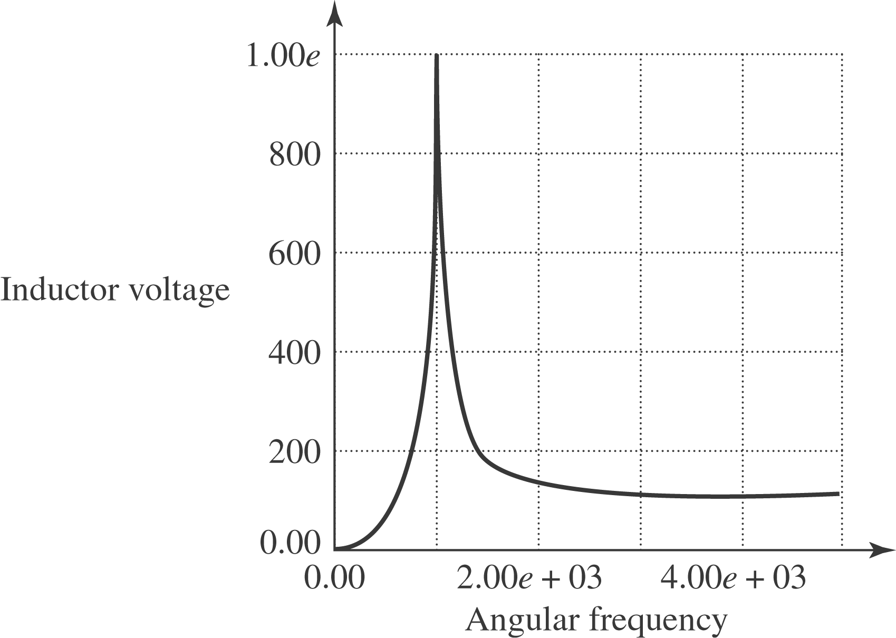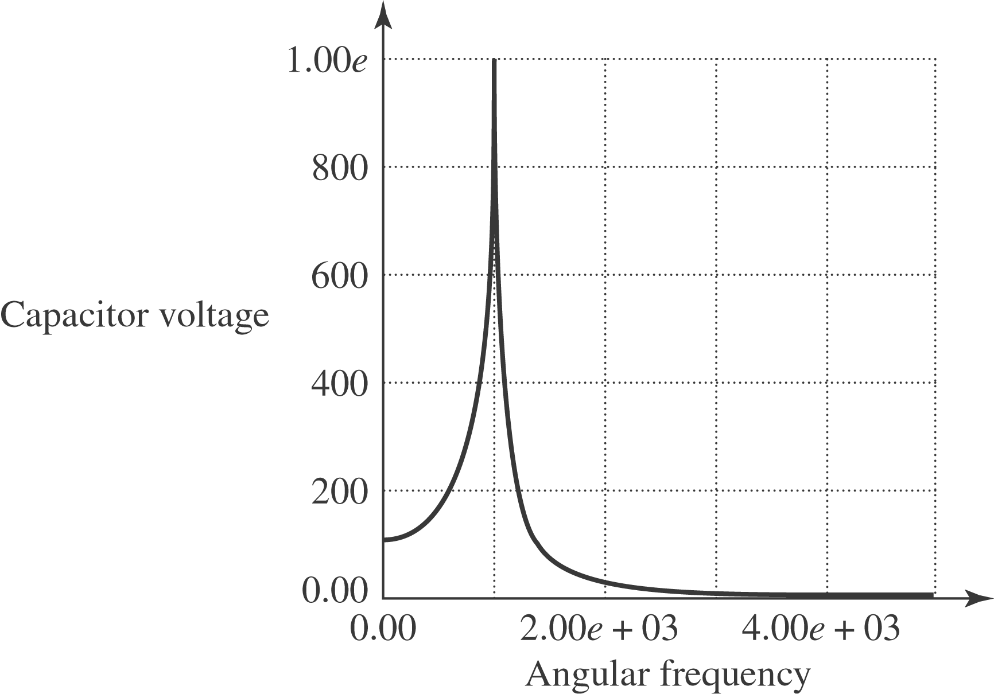

d) When the angular frequency is zero, the inductor has zero voltage while the capacitor has voltage of 100 V (equal to the total source voltage). At very high frequencies, the capacitor voltage goes to zero, while the inductor’s voltage goes to 100 V. At resonance, 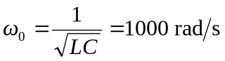, the two voltages are equal, and are a maximum, 1000 V.

